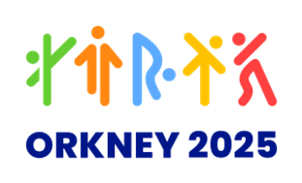**Mascot Design Competition**

Did you see the pictures of the Guernsey 2023 International Island Games and their mascot, Jet the Puffin? Orkney will be hosting its own Games in less than two years, and we need YOU to design the mascot! It can't be a Puffin and it can't be called Jet, but apart from that, you can design whatever mascot you'd like, and don't forget to give it a name!

Name: Age:

School: OR Parent’s Name:

Email address:

Class: Phone number:

Draw your Mascot here!

Suggested name for your mascot

Rules: 1. All entries must be by children of school-age.

2. The competition closes on Friday 29 September; any entries received after this time will not be accepted.

3. Entries cannot be returned so please consider taking a copy before submission.

4. Email your entry to [info@orkney2025.com](mailto:info@orkney2025.com) or send to Orkney 2025, 2 West Tankerness Lane, Kirkwall, KW15 1AL